11 Training Sets 20 Validation Sets
Random Forest (n=20, max_depth=10, random_state=42)

Mean Squared Error for Synthetic Planetscope DOY 222: 0.0003832848208237533
Mean Squared Error for Resampled Planetscope DOY 222: 0.06529027223587036
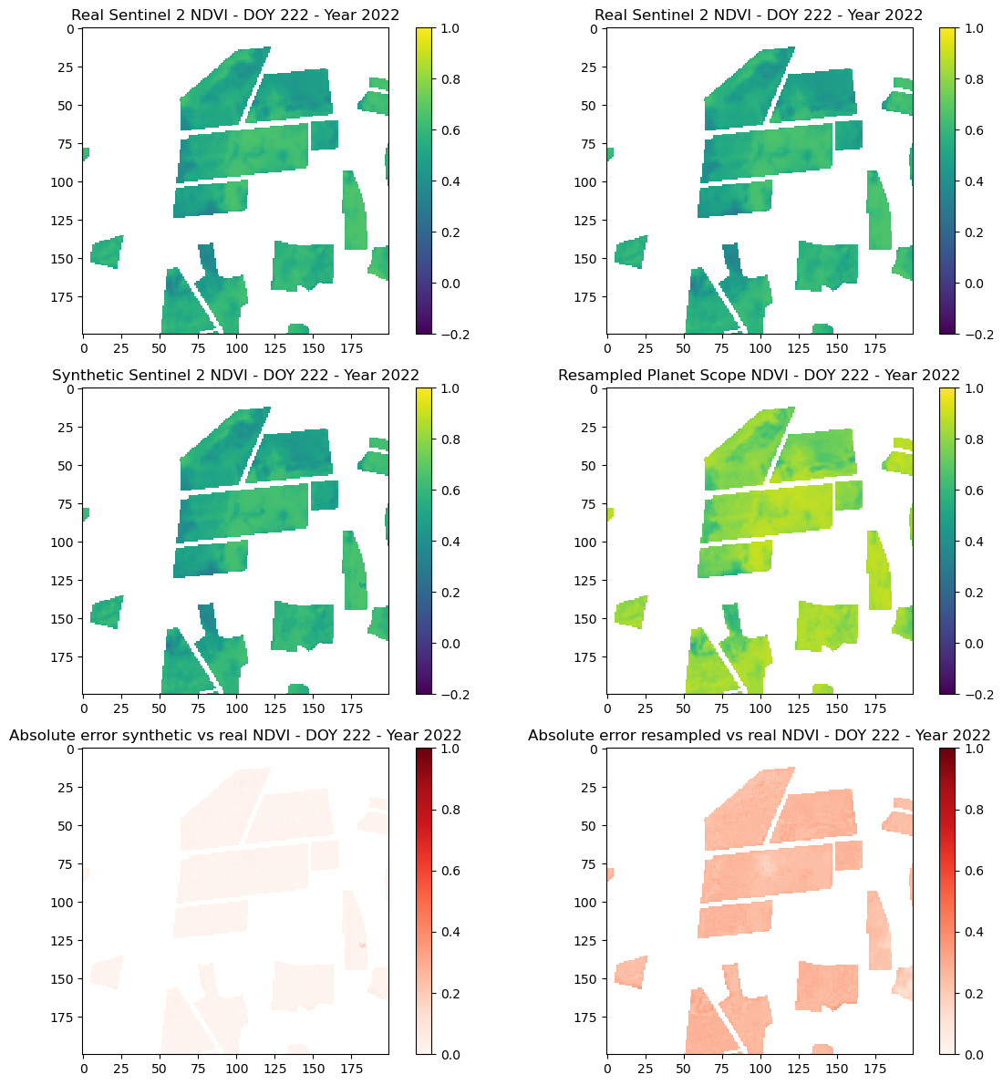
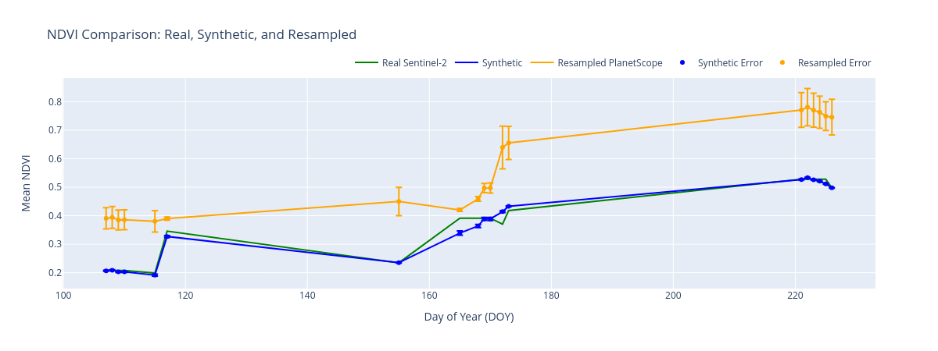
Total Error Resampled: 0.7725465749390423
Total Error Synthetic: 0.05188186266759507
11 Training Sets 20 Validation Sets
Linear Regression

Mean Squared Error for Synthetic Planetscope DOY 222: 0.0014139999535743035
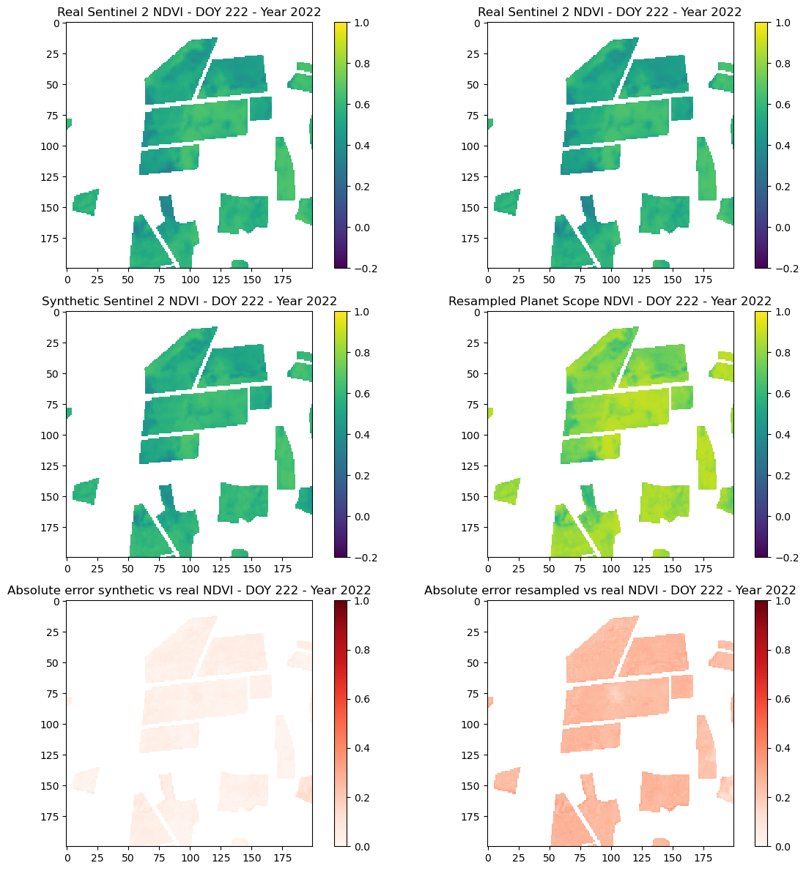
Mean Squared Error for Resampled Planetscope DOY 222: 0.06529027223587036
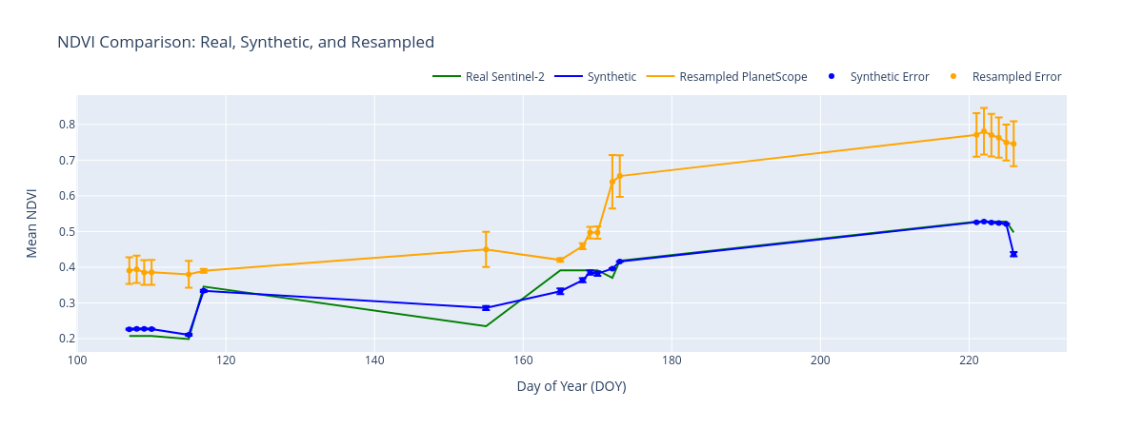
Total Error Resampled: 0.7725465749390423
Total Error Synthetic: 0.05338310391698836
26 Training Sets 5 Validation Sets
Random Forest (n=40, max_depth=15, random_state=42)

Mean Squared Error for Synthetic Planetscope DOY 223: 0.00029908717886261116
Mean Squared Error for Resampled Planetscope DOY 223: 0.05951601639389992
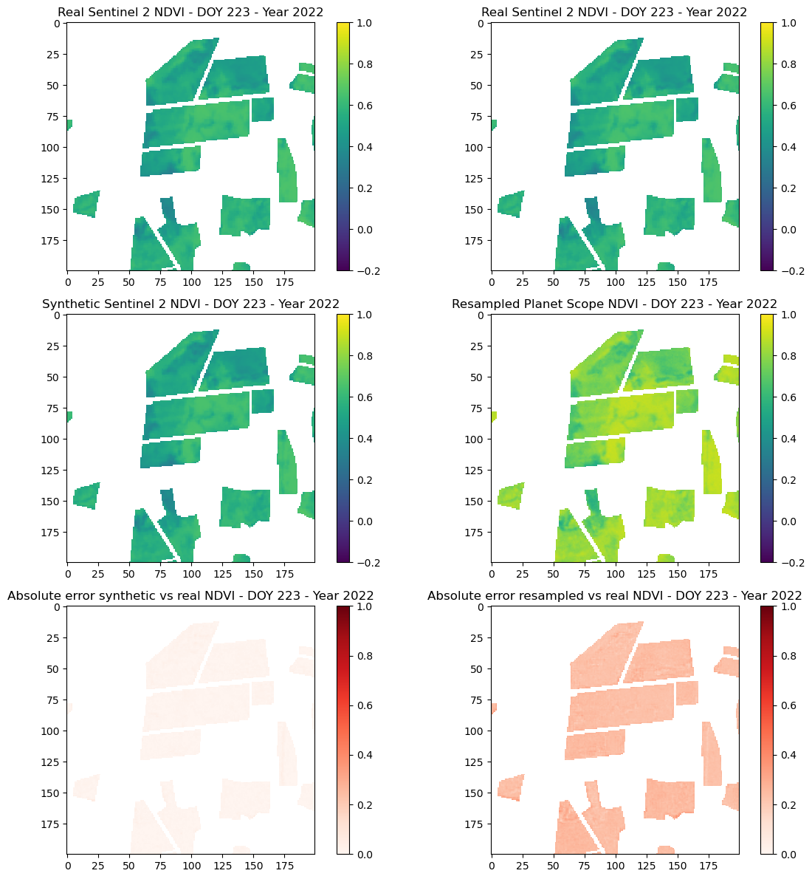
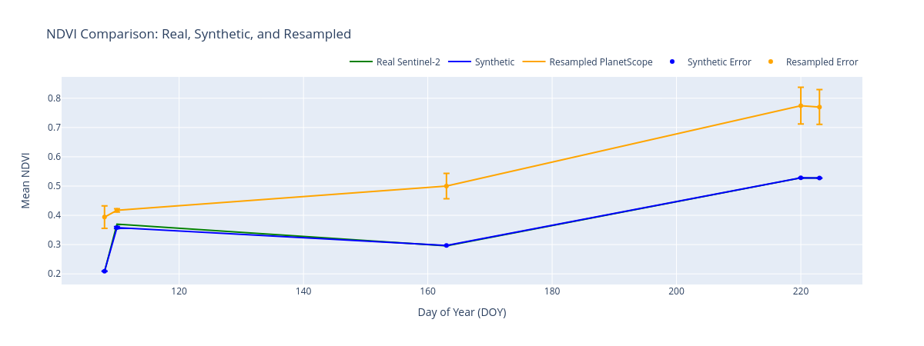
Total Error Resampled: 0.20973287569358945
Total Error Synthetic: 0.004901797278193261
26 Training Sets 5 Validation Sets
Linear Regression
Mean Squared Error for Synthetic Planetscope DOY 223: 0.0008730182090968774
Mean Squared Error for Resampled Planetscope DOY 223: 0.05951601639389992

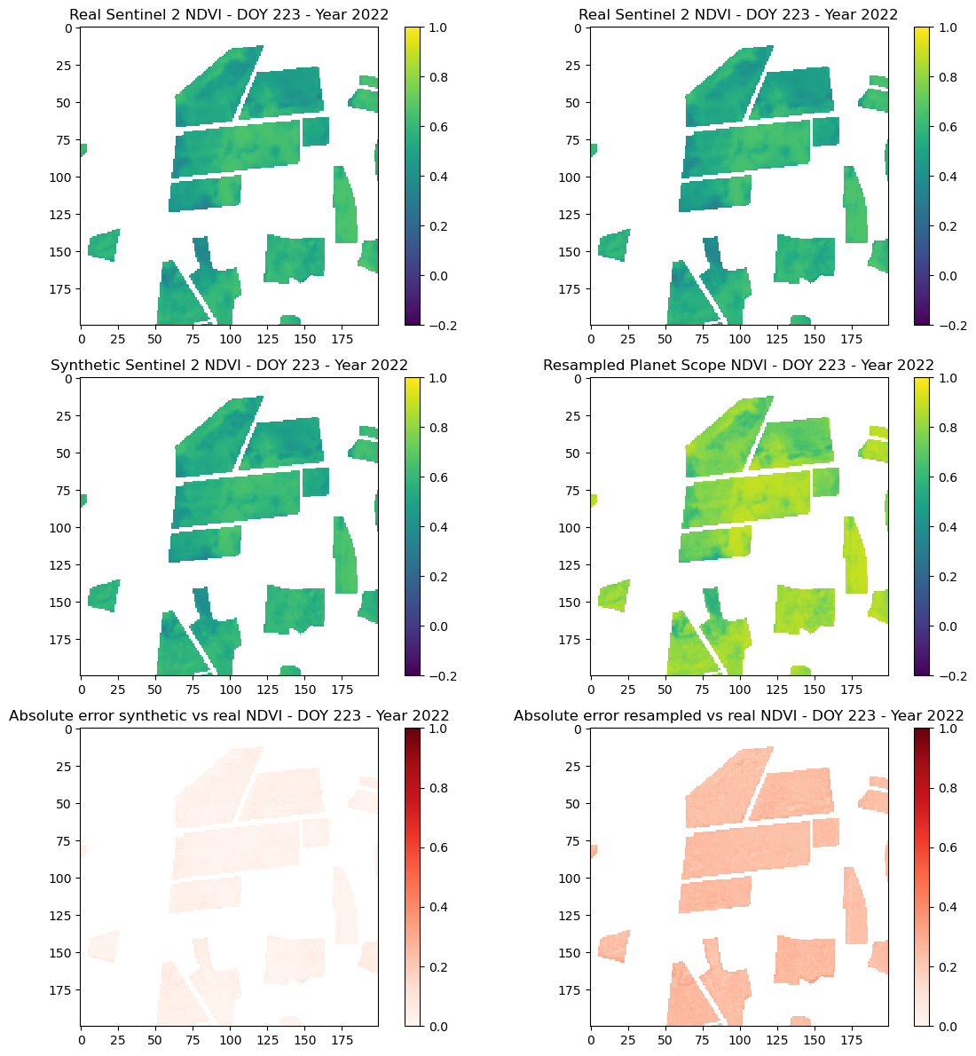
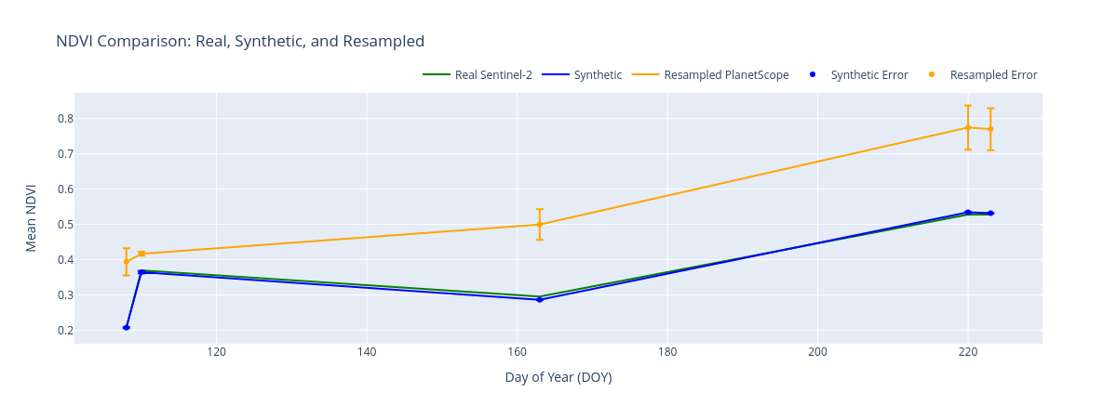
Total Error Resampled: 0.20973287569358945
Total Error Synthetic: 0.008213434777738475

